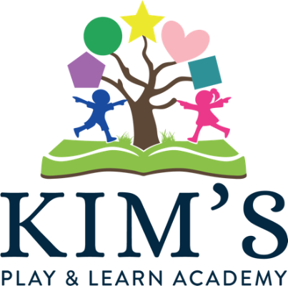

Enrollment Checklist

Kim’s Play & Learn Academy admission process is designed to find families looking for a unique educational experience. Our goal is not to fill openings, but rather to gather together children who will blossom within our program.

Upon receipt of the enrollment application, prospective parents will meet privately with our Tour Guide and Director for an informal discussion of classroom procedures, expectations, and objectives. Parents are also strongly encouraged to observe a class.

To Apply:

1. _____ Submit an enrollment Application
2. _____ Submit a New Student Enrollment Fee - $100.00
3. _____ New Family Fee- $200.00

Once an applicant is accepted, the parents will complete and submit the Admission Packet. This must be received two weeks before the first day of class. Required emission forms include:

To complete Enrollment:

1. _____ Parent Commitment Agreement
2. _____ Admissions Information
3. _____ Operational Discipline and Guidance Policy
4. _____ CACFP Meal Benefit
5. _____ Social Media and Video Website and Permission Form
6. _____ Transportation/Field Trip & Water Play Permission Form
7. _____ Physical Form
8. _____ Permission to Photo
9. _____ Family Photo
10. _____ Student Photo
11. _____ Family Orientation Checklist

Additional paperwork requested, but not required for enrollment:

1. _____ Food Allergy and Emergency Plan (if applicable)

We sincerely appreciate your interest in Kim’s Play & Learn Academy. Just as you have high hopes and dreams for your child, we our Academy will grow over the next few decades to become a world-class Academy. We have crafted the admission process with this in mind and we are grateful for your commitment to move through the process with us.

